**Capabilities covered:**

1. Ability to understand various ways of finding webelements and demonstrate the locating and its usage in Selenium Web Driver
2. Ability to handle mouse movements and keyboard events
3. Ability to download and configure Selenium Web Driver with Eclipse and also Ability to install and use Selenium IDE with Ability to use Firebug and Firepath
4. child and parent windows
5. Ability to handle dynamic web elements
6. Ability to understand and demonstrate to handle windows, frames, alerts and taking screenshot using Selenium Web Driver
7. Ability to accessing links and tables using Selenium Web Driver
8. Running TestNG Test Suite with different tests
9. Generate logs and Reports using TestNG

**Problem statement: Login To online shopping website (amazon.in) and add 2 or more items to cart for checkout.**

**STEP 1: Login to amazon.in**

* Mouse hover on sign in button (use actions class for mouse movement) and click on sign in.
* Enter Credentials and sign in to website.

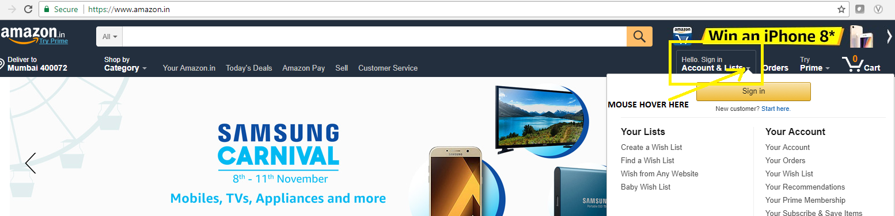

**STEP 2: Search for an item and add it to cart.**

* Goto search box at the top and search for an item category (say refrigerator) in Uppercase by holding **SHIFT** KEY on keyboard(make use of actions class) and hit **ENTER** KEY on keyboard.
* Select the first relevant item and it to cart by navigating to new window which opens when clicking on the item.

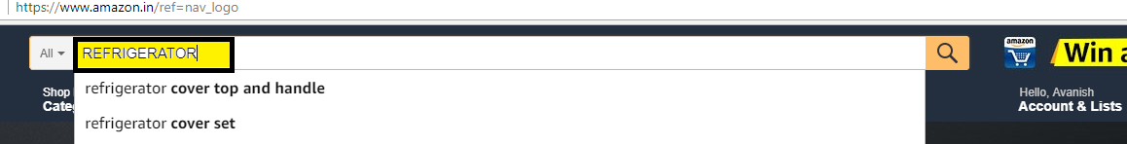

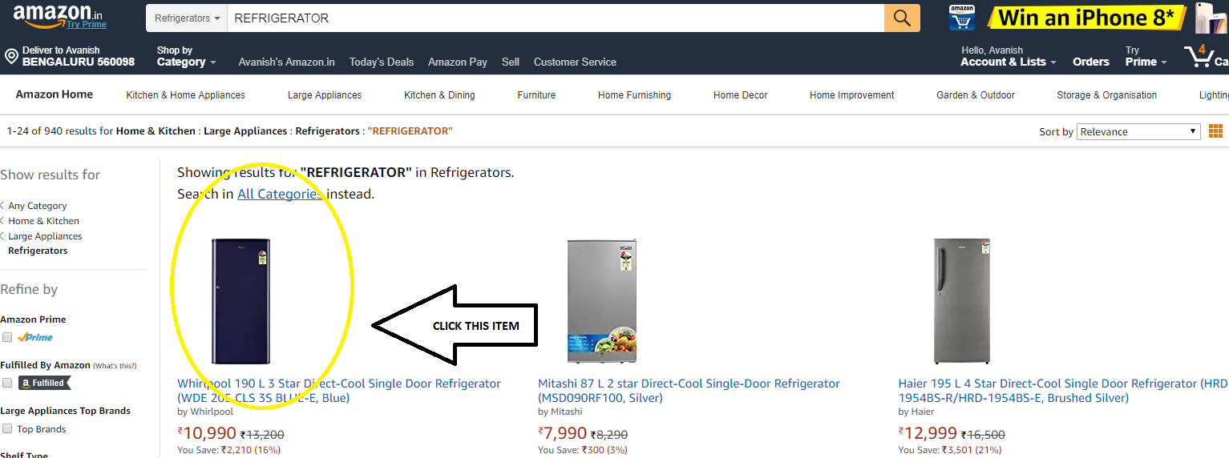

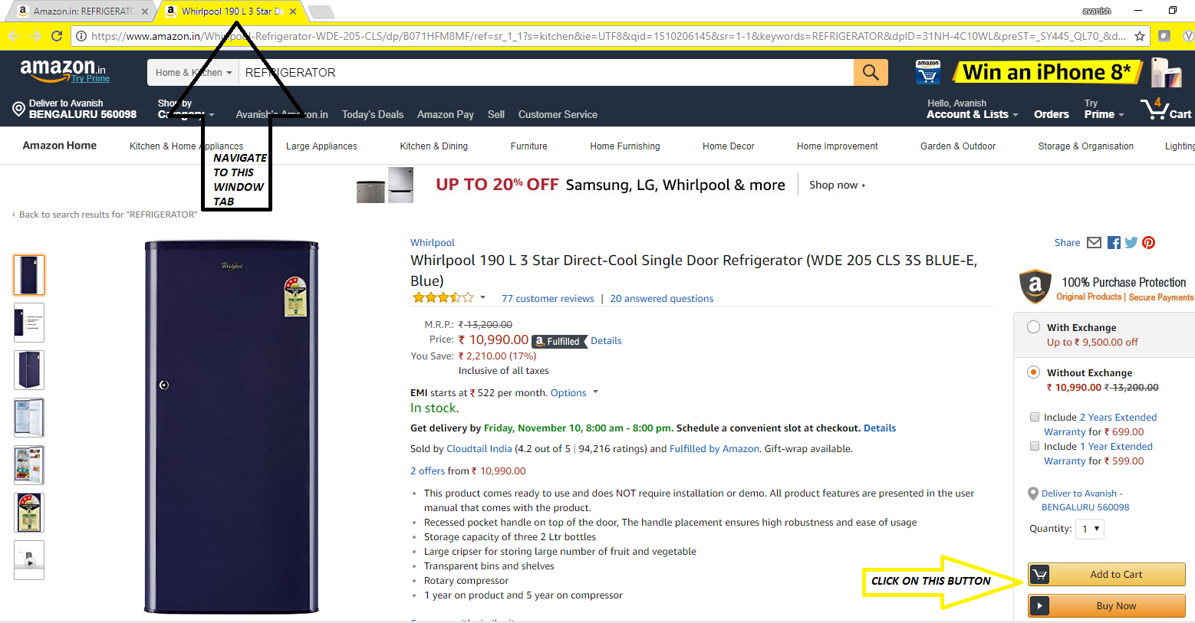

**STEP 3: Add second item to the cart**

* Navigate back to the previous home window and repeat step 2 for second item category (say Washing Machine).
* Add it to cart and proceed for checkout.
* Take Screenshot for the evidence of checkout.

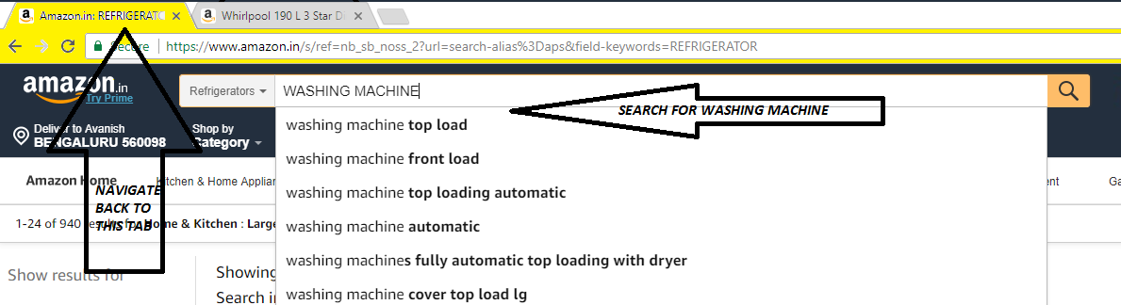

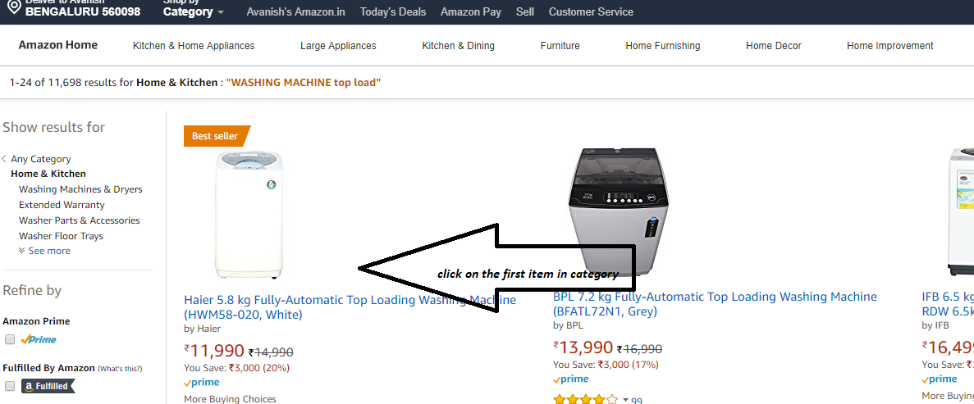

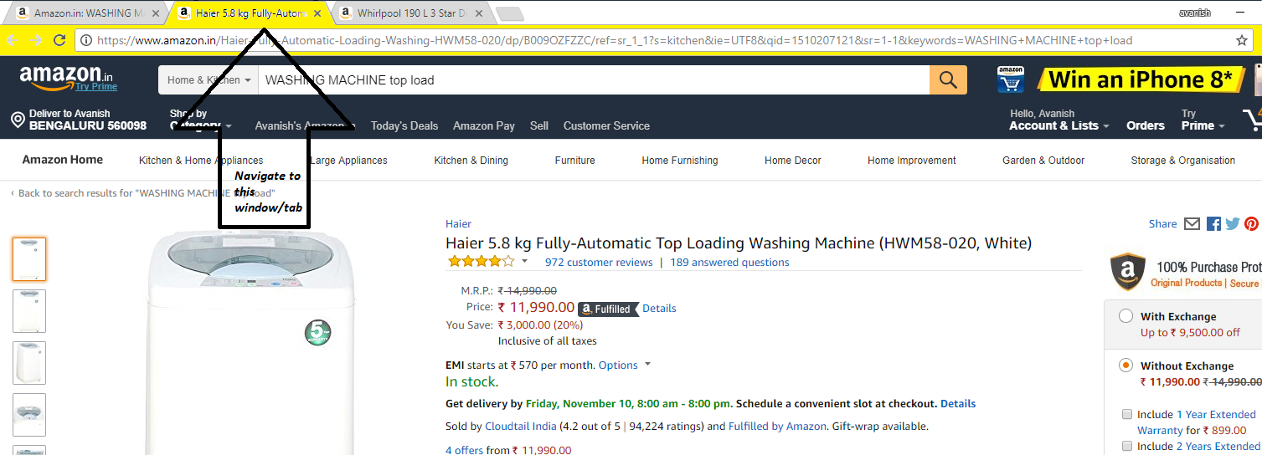

**RULES**

* Make use of @Test annotation of testng to differentiate tests based on category and execute each test separately.
* Make use of grouping feature of testng to divide tests based on categories and execute only group of test cases which are required.
* Make use of log4j to log different level of logs.
* Generate testng reports for the execution.